**­­**

**CS 480**

**Design Document**

**Template**

**Document Control**

Document Information

|  |  |
| --- | --- |
| **©** | **Information** |
| Document Owner | *[Team Name]* |
| Issue Date | *[Date]* |
| Last Saved Date | *[Date]* |
| File Name | *[Name]* |

Document History

|  |  |  |
| --- | --- | --- |
| **Version** | **Issue Date** | **Changes** |
| *[1.0]* | *[Date]* | *[Section, Page(s) and Text Revised]* |
|  |  |  |
|  |  |  |
|  |  |  |

**Table of Contents**

1. Introduction

1.1. Purpose

1.2. Scope of the project

1.3. Glossary

1.4. References

2. Software Design

2.1. System Architecture

2.2. Component X

2.2.1. Component Tasks

2.2.1.1. Task Z of Component X

3. Data Design

3.1. Persistent Data

3.2. Transient/Dynamic Data

3.3. External Interface Data

3.4. Transformation of Data

3.5. Data Dictionary

4. User Interface Design

4.1. User Interface Design Overview

4.2. User Interface Navigation Flow

5. External Interfaces

5.1. Interface X

6. Requirements Traceability Matrix

# Introduction

## Purpose

## Scope of the project

The activities and tasks defined in the project plan must be undertaken within the scope of the project. For this reason, reiterate the scope of the project here as defined in the Project Plan.

## Glossary

Define any terms unique to this project.

## References

Provide references as needed.

# Software Design

## System Architecture

Describe and include a figure of the overall system architecture, including all major components and their relationships to each other

## Component X

Provide a comprehensive high-level description for each major component. Include database domain, stored procedures, triggers, packages, objects, functions, etc.

## Component Tasks

## Task Z of Component X

Provide an activity diagram for each task and describe the data flow and functionality of the task the component performs.

# Data Design

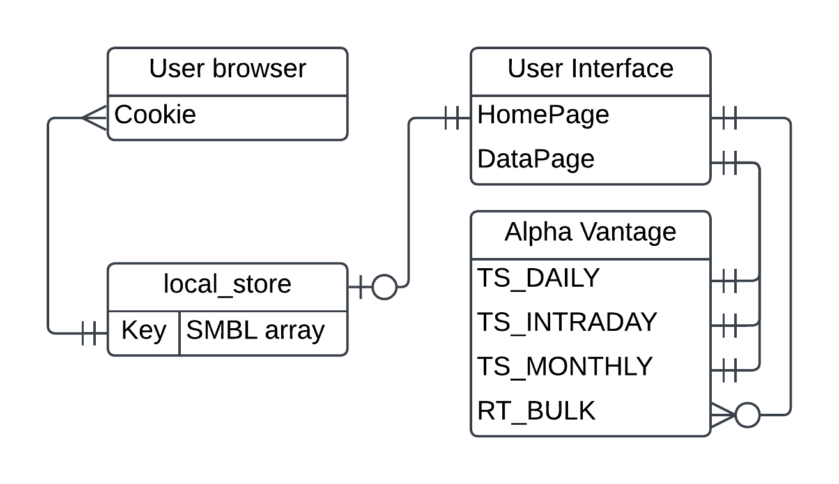

## Persistent Data

The only persistent data that will be maintained is that within the local_store. This will be a series of string arrays that contain the stock symbols that use user has selected. This will be referenced by reading the cookie established in the user’s browser to make sure the correct array is being accessed.

## Transient/Dynamic Data

Our transient data is that which we will display onto the home page and data page after formatting. On the HomePage this includes the current stock delta as calculated using the SMBL_array and the API function REALTIME_BULK_QUOTES. On the DataPage this the information shown in the stock performance graph as gathered by the various TIME_SERIES_X API calls.

## External Interface Data

The data we will be getting from external interfaces can be narrowed down to four different API calls. Those are REALTIME_BULK_QUOTES for populating the home screen with information from user selected stock symbols, and the TIME_SERIES_X calls for showing stock performance over time. Specifically we will use TIME_SERIES_INTRADAY, TIME_SERIES_DAILY, and TIME_SERIES_MONTHLY.

## Transformation of Data

All data receive from alpha vantage will have to be process before being presented to user. This is simple for the HomePage as all we have to present for each stock is the current price and Delta from last close. For the DataPage we have to take the raw information and plot performance over time. This plotting transformation will also depend on the user input for the timeline start point.

## Data Dictionary

Provide a brief description of each data element

(Example of a database table description)

|  |  |  |
| --- | --- | --- |
| **Table/Class Name** | | |
| **Attribute** | **Notes** | **Type** |
| Attribute 1 | Description of the attribute | Data type of the attribute |
| Attribute 2 | Description of the attribute | Data type of the attribute |
| Attribute 3 | Description of the attribute | Data type of the attribute |

# User Interface Design

## User Interface Design Overview

Describe and illustrate the overall user interface design.

## User Interface Navigation Flow

Diagram the flow from one screen to the next

# External Interfaces

Identify any external interfaces used in the design

## Interface X

Describe interactions, protocols, message formats, failure conditions, handshaking, etc. for each interface

# Requirements Traceability Matrix

Provide an updated requirements traceability matrix that maps each design component to the appropriate requirement and use case.